create procedure STD

AS

BEGIN

Select \* from Student;

END

execute STD

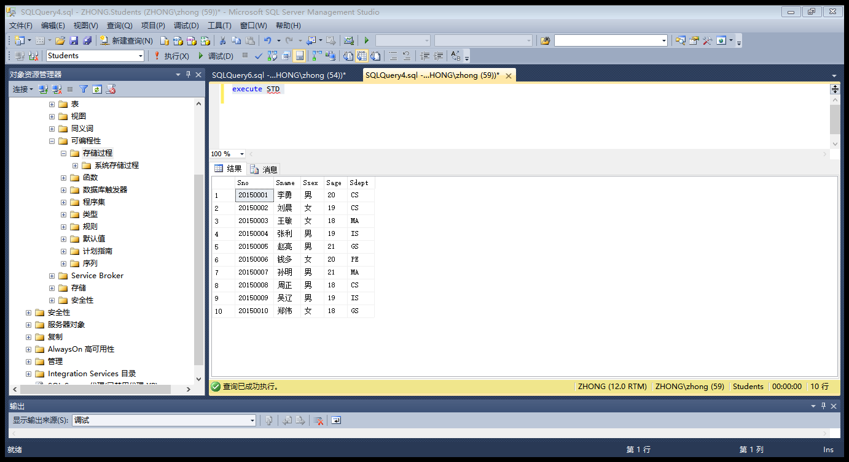

create procedure SelectStdBySno @sno char(9)

as

begin

select \*from Student where Sno=@sno;

end

execute SelectStdBySno'20150003';

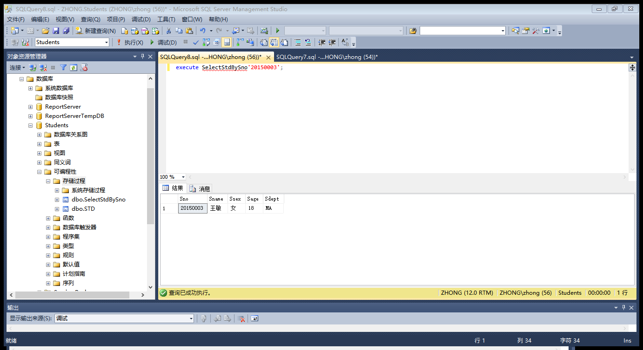

create procedure SelectSnameBySno @sno char(9),@stuname char(20) output

As

Begin

Select @stuname=Sname from student where sno=@sno;

End

Declare @name char(20);

Execute SelectSnameBySno '20150008',@name output;

Select @name as 学生姓名

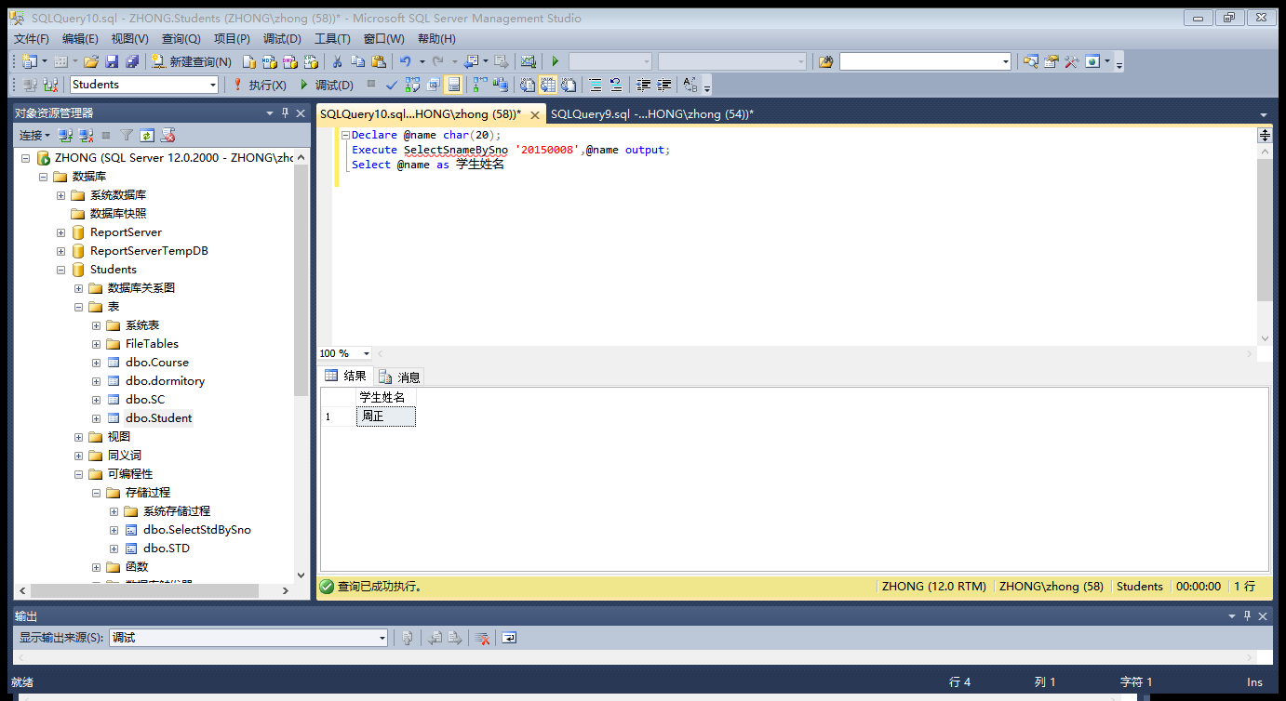

create procedure DelSnameBySno @sno char(9)

as

begin

delete from Student where Sno = @sno;

end

execute DelSnameBySno'20150002'

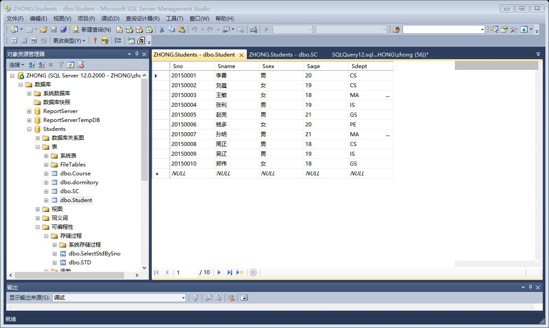

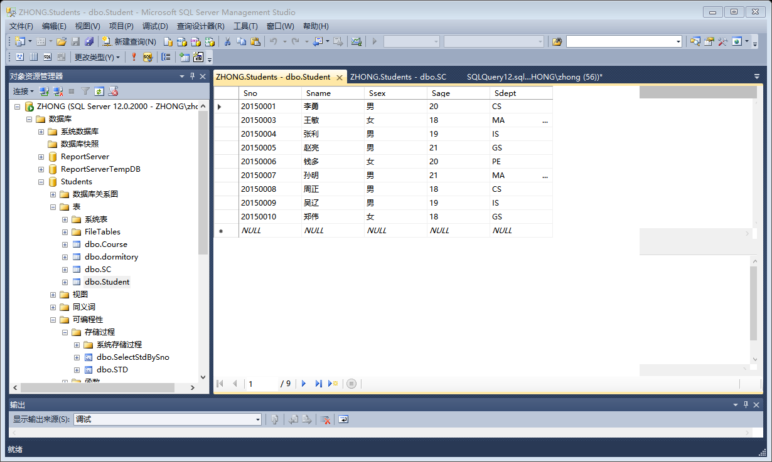

create procedure UpdateIfBySno @sno char(9),@sname char(9),@sex char(2),@age smallint,@dept char(9)

as

begin

update Student

set Sname=@sname,Ssex=@sex,Sage=@age,Sdept=@dept where Sno = @sno;

end

execute UpdateIfBySno '20150004','哈哈哈','女',28,'PE'

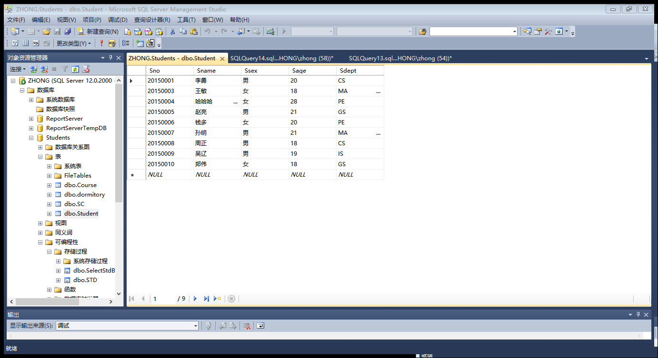

create procedure InsertStd @sno char(9),@sname char(20),@sex char(2),@age smallint,@dept char(9)

as

begin

insert into Student(Sno,Sname,Ssex,Sage,Sdept)

values(@sno,@sname,@sex,@age,@dept)

end

exec InsertStd '20150022','刘凡','男',20,'IS'

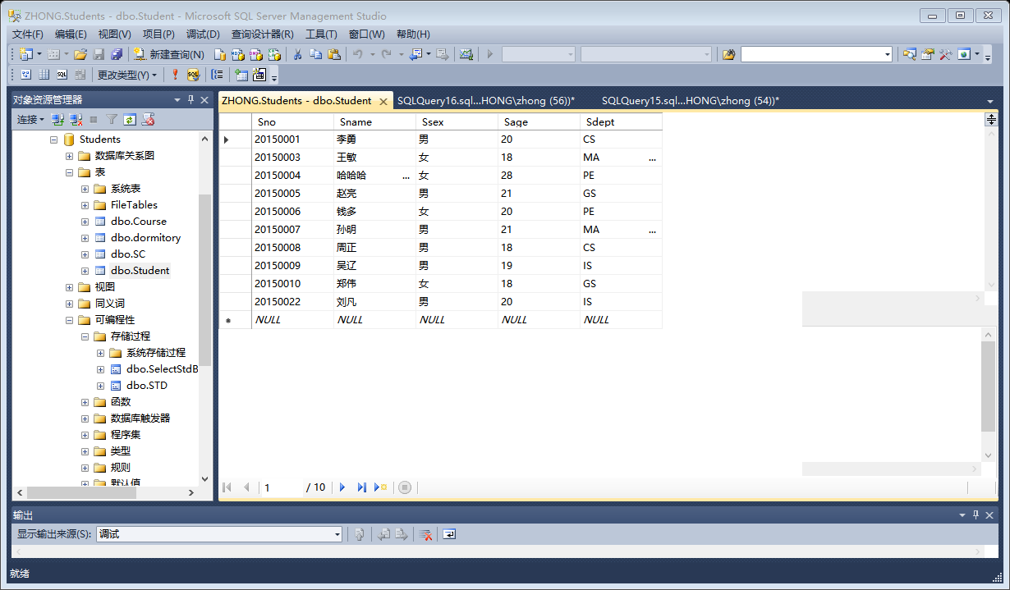

create procedure SelectGradeBySname @name char(20)

as

begin

select Grade from SC where

Sno = (select Sno from Student where Sname=@name)and

Cno = (select Cno from Course where Cname ='PASCAL语言');

end

exec SelectGradeBySname '孙明'

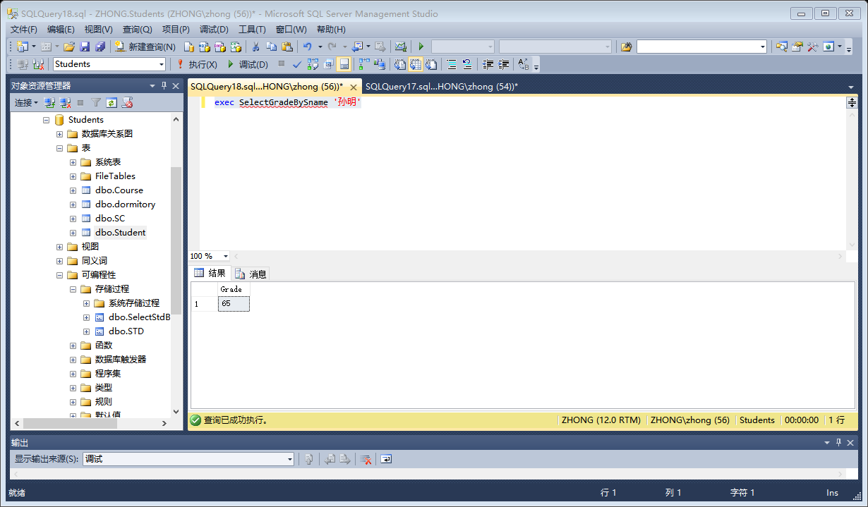

create procedure SelectHiGrade @cname char(9)

as

begin

select Sno,Grade from SC

where Cno = (select Cno from Course where Cname = @cname) and

Grade>(select avg(Grade)from SC where

Cno = (select Cno from Course where Cname=@cname));

end

exec SelectHiGrade '离散数学'

